**SHORT-TERM CONTRACT FOR MODELLING APPROACHES: SUPPORT TO BFT**

**ASSESSMENT (GBYP 07/2017) OF THE ATLANTIC-WIDE RESEARCH PROGRAMME ON**

**BLUEFIN TUNA (ICCAT-GBYP – Phase 7)**

Tom Carruthers, Blue Matter Science Ltd. (bluemattersci@gmail.com)

17th July 2017

**Progress Report 6 including workplan**

**Executive summary**

Progress from September 2016 – February 2017. The previous contract saw the development of a fully functional R package for developing and testing MPs for various Atlantic bluefin tuna operating models including full documentation and tutorials.

Progress from May 2017 – July 2017. Prior to the assessment meeting the priority has been updating the various data and fitting the latest operating models accounting for the recommendations of the CMG report.

Status of MSE framework. MSE development in terms of functionality is the same as September 2016 and requires two principal inputs from a wider group: **management objectives** (performance metrics) and **management procedures** (Figure 1)

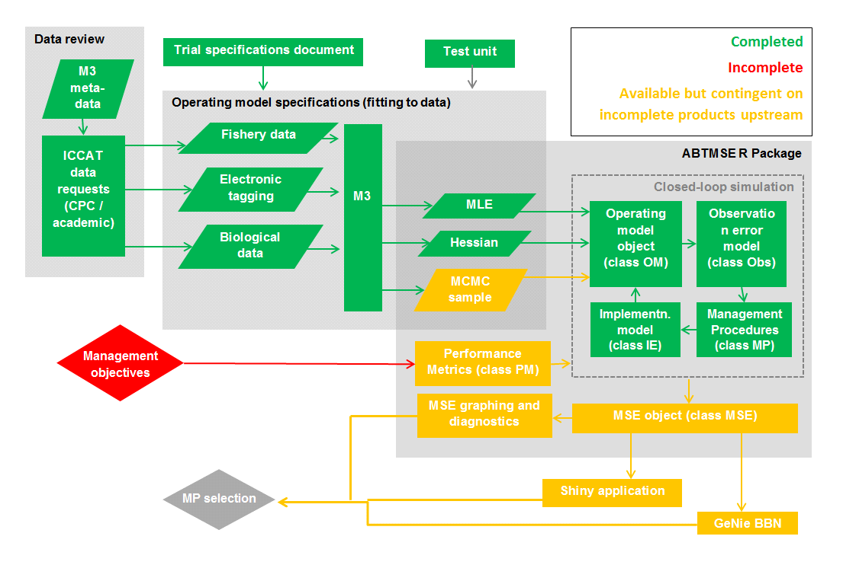

Figure 1. MSE status.

**Progress in previous contract since Progress Report 5 (Sept 2016 - Feb 2017)**

***Data***

- Following the data preparatory meeting the fleet structure and data formats were finalized and the meta-database was updated.

- The fishery, survey, tagging and stock of origin data were formatted for the operating model

- [A draft SCRS paper](https://drive.google.com/open?id=0B0HYOP0BN5RPN3VxTmo4SVZqQUE) was written that provides a full account of the derivation of the ‘master index’ that is central to the operational modelling.

- The online [meta-data summary](https://drive.google.com/open?id=13pFaM3BTnzQ1BNQGoYn4O2n1IeD18V3VTbN9Hv7139U) was linked to the corresponding sources of data in the GitHub repository.

***Operational modelling***

- A final operating model structure ([M3 v1.4](https://drive.google.com/open?id=0B0HYOP0BN5RPYkJ4X0QydjZUNGM)) was designed following feedback from the Core Modelling Group including a new model initialization by stock reduction analysis to account for catches before 1960

- The new operating model was simulation tested to check for coding errors, identifiability and to establish suitable data weightings

- The trial specifications document was updated following feedback from the core modelling group

***MSE development***

- The 18 reference operating models were fitted to data and reproducible [R scripts](https://drive.google.com/open?id=0B0HYOP0BN5RPUThxcWJ1b1p2dHM) are available that describe this process.

- A [standard operating model fitting report](https://drive.google.com/open?id=0B0HYOP0BN5RPYXNWVHdxSjNTa2s) was developed in R markdown and these were generated for each reference operating model.

- A comprehensive set of R functions were developed to allow for the simple and rapid design of operating models, fitting of operating models to data, design of management procedures, specification of performance metrics and the running of Management Strategy Evaluation

- All of the R code, data and objects were compiled into a single R package ([ABTMSE](https://drive.google.com/open?id=0B0HYOP0BN5RPeDJYVE5mT0FGSTg)) with complete documentation for all functions, objects and data to be used in MSE analyses.

- The raw data, R scripts, Reports, help documentation and the R package were assembled in a single directory which can be downloaded from the [ICCAT GitHub repository](https://github.com/ICCAT/abft-mse).

***Documentation***

- An extensive user guide was developed in R markdown that describes the file structure, the project and guides users through the various functions of the R package including worked examples of the 7 steps of MSE development (of Punt and Donovan, 2007)([Appendix 4](https://drive.google.com/open?id=0B0HYOP0BN5RPV1BXOGk0cEwyTGM)).

- A fully documented website was produced using ‘pkgdown’ that can act as the front page of the ICCAT abft-mse repository and has links to various documentation including all the functions and objects of the R package ([Appendix 5](https://drive.google.com/open?id=0B0HYOP0BN5RPS0l6Q2cwb1FpVU0))

- Software design documentation for the M3 assessment model, ABTMSE R package and an M3 guide.

**Progress in current contract since Progress Report 5 (May 2017 - July 2017)**

***MSE documentation updates***

- Trial specifications document

- Updated standard operating model report

***Data update for OM conditioning***

- Latest PSAT tagging data (provided by M. Lauretta)

- Master index recalculated to include assessment CPUE indices (additional trend information, spatial and seasonal distribution still determined by Task II CPUE)

- 2017 Assessment compatibility

* Fishery CPUE indices
* Updated fleet definitions
* Spawning biomass indices
* New mortality at age schedule
* New maturity (spawning fraction) at age schedule
* New growth model (with length based variability calculation)
* Latest CATDIS data
* Latest Task II CPUE
* Updated size composition dataset

***Operating model structure updates***

- Move to 2-year recruitment estimates

- Initialization by master index but then F modification by season and area (allowing for seasonal shifts in spatial distribution to fit electronic tags and stock of origin data). Essentially 40 additional parameters have been added (10 areas x 4 seasons) to allow greater flexibility to fit existing data and rely less on the structure imposed by the master index.

- Stock reduction initialization moved up from 1960 to 1981 to avoid attempting fit to inconsistent fishery composition data.

***Fixes to ensure model stability***

- To avoid generation of spatially cryptic biomass, stock of origin data for stock-specific areas were invented. For example 100 observations of Eastern fish in the South East Atlantic but no observations of Western fish. Similarly, 100 observations of Western fish in the Caribbean but no observations of Eastern fish.

- Given that the electronic tag and stock of origin data do not cover all age classes, areas and seasons the gaps can lead to cryptic biomass in areas/seasons where there are no catches. This creates instability in model predictions of the magnitude of the two stocks. To prevent the optimization from exploring these parameter vectors, a weak prior on the eastern to western stock ratio of 8:1 was included.

**Current status of deliverables and actions required to achieve them**

|  |  |  |
| --- | --- | --- |
| **Deliverable 1 July 20, 2016 (100%)** | | |
|  | i | Workplan outlining the actions required to complete the final deliverables |
|  | ii | Presentation and short report summarizing current status of deliverables and actions required to achieve them |
|  |  |  |

The workplan (deliverable i) is included in Section 5 below. The purpose of Progress report 5 and accompanying presentations was to address deliverable ii.

|  |  |  |
| --- | --- | --- |
| **Deliverable 2 September 23, 2017 (0%)** | | |
|  | i | Updated presentations and short report summarizing current status of deliverables and actions required to achieve them |
|  | ii | Examples based on agreed trials, to include output statistics and fully OM conditioning diagnostics |
|  | iii | Draft papers on application of MSE |
|  |  |  |

|  |  |  |  |
| --- | --- | --- | --- |
| **Deliverable 3 November 3, 2017 (0%)** | | | |
|  | i | Updated presentations and short report summarizing current status of deliverables and actions required to achieve them |
|  |  |  |

|  |  |  |
| --- | --- | --- |
| **Deliverable 4 February 21, 2018 (0%)** | | |
|  | i | Updated **Repository** with full tracking including version control for software development  <https://github.com/ICCAT/abft-mse> containing the OM |
|  | ii | Update of **SDP** (Software Development Plan) that will be reviewed by external experts, as agreed at Monterey meeting |
|  | iii | **Test Unit** so that code can be validated |
|  | iv | **Meta Database** summarizing all parameters and assumptions used  https://github.com/ICCAT/GBYP-MetaDB |
|  | v | Evaluation of **Management Procedures** implementation by 3rd parties.  Written up as SCRS papers and code available in repository |
|  |  |  |

**Current status of objectives**

|  |  |  |  |
| --- | --- | --- | --- |
| **Objective** | | | **Tasks (bold are completed)** |
|  | **i**  (100%) | Ensure the Operational Model (OM) implements the trials as specified by the 2016 CMG report. | **Added (M3 v1.4):**  **age-based movement, plus group, model initialization at equilibrium estimated F, recruitment predicted from SSB in previous year, a prior for depletion to allow the model to fit specified depletion.** |
|  | **ii**  (100%) | Us the test unit to validate the age-based movement model | **Test unit is being updated to match developments in the operating model** |
|  | **iii**  (0%) | Work with third parties to add MPs to the MSE framework including empirical control rules and simple stock assessment methods | Reach out to national scientists, members of the BFT WG (possibly leverage the chairs of Eastern and Western WGs) and the CMG to develop new MPs or to incorporate existing MPs (e.g. CCSBT) |
|  | **iv**  (0%) | Run the MSE in collaboration with BFT Species group | Requires a dedicated meeting following finalization of the TS, fitting of the appropriate OMs and integration of these into the R ABT-MSE framework. |
|  | **v**  (50%) | Collaborate with the SCRS and others (e.g. rRFMOs) to develop interactive web based graphics to communicate MSE results to decision makers and stakeholders. |  |
|  | **vi**  (100%) | Work with other to update and maintain the meta database of the available bluefin data and knowledge <https://github.com/ICCAT/GBYP-MetaDB> | **The meta database has been made publically available and editable** [https://docs.google.com/spreadsheets/d/ 13pFaM3BTnzQ1BNQGoYn4O2n1IeD18V3VTbN9Hv7139U/ edit#gid=1352276725](https://docs.google.com/spreadsheets/d/%2013pFaM3BTnzQ1BNQGoYn4O2n1IeD18V3VTbN9Hv7139U/%20edit) |
|  |  |  |  |

**Workplan for achieving deliverables**

***Deliverable 2ii. Examples based on agreed trials, output statistics, conditioning diagnostics***

A summary report of OM conditioning should be circulated to the CMG and BFT working group. An initial SCRS paper (SCRS/2017/139) has been submitted to this meeting detailing results of the early operating models. Operating model fits for all reference OMs are also to be provided to the CMG. The central challenge of finalizing operating models rests on the CMG (via requests / updates by the technical assisstant).

***Deliverable 2iii. Draft papers on applications of MSE***

A Two peer-review papers are being drafted:

“Strategies and Tactics in the Campaign for Sustainability of Atlantic Bluefin Tuna”

“Managing complex fisheries using gene tagging”

In addition, at least one SCRS paper should provide the results of MP testing.

***Deliverables 4i – 4iv. Updated repository, SDP, test unit, meta database***

The most straightforward of the deliverables this simply requires an update in the various products.

***Deliverable 4v. Evaluation of Management Procedures implemented by 3rd parties***

Develop interest among bluefin tuna working group attendees on development / co-development of MPs.

Reach out to interested parties and develop their MP ideas in collaboration.

At September meeting demonstrate MP development and testing (possibly organize a webinar among collaborators in the interim).

Produce and SCRS paper documenting the results of MP MSE testing.